SUDS Athlete Registration Form 2023
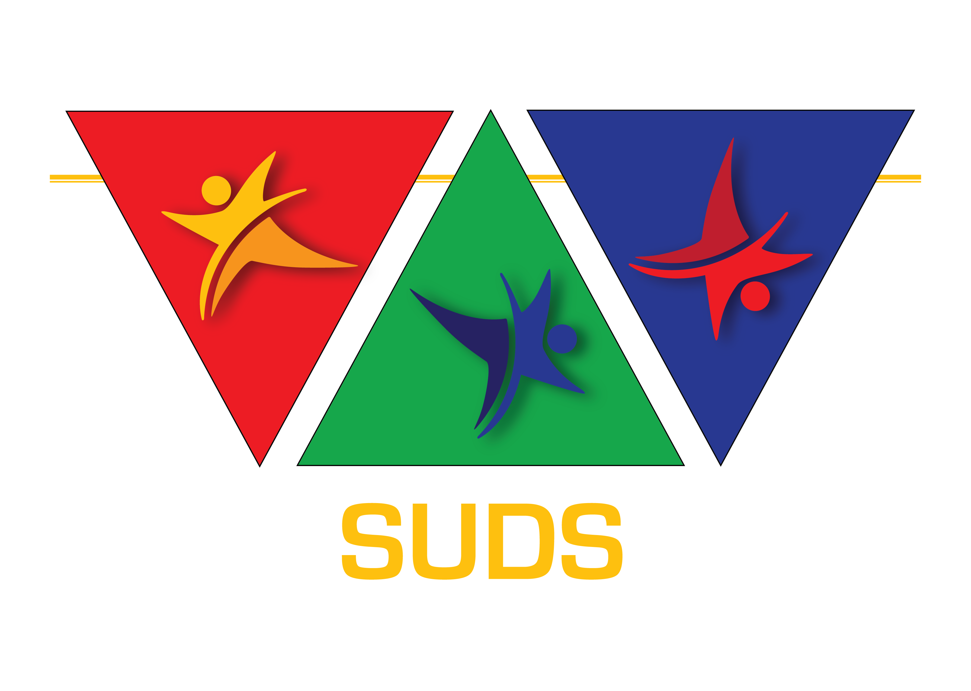

Athletics – IAADS (Track & field) Basketball – IBA21
Football – FIFDS Gymnastics–DSIGO Handball – Handown Judo – JUDOWN Swimming – DSISO (Race & Artistic) Ski – SKIDS Table Tennis – ITTADS Tennis – Tennis

Swimming and Gymnastics have an extra medical form to be downloaded and completed

INDEX

Page | Section | Content
1 | Section A | Athlete registration
2 - 4 | Section B | Medical
5 - 6 | Section C | Consent
7 | Section D | Payment details

ATHLETE REGISTRATION FORM
CONFIDENTIAL
(Please complete in English)

Athlete name |  | Date
Sport
ATHLETE INFORMATION – COMPLETE THE FOLLOWING FROM YOUR PASSPORT |  |  |  |  |  |  | INSERT PHOTO
Surname (Family name)
First name (Given name)
Date of birth dd/mm/yyyy |  |  | Male☐ Female ☐
Nationality
Passport number |  |  | Expiry date
PARENT/GUARDIAN DETAILS
Name
Address
Contact no |  |  |  | Mobile no
Email
Relationship
NATIONAL ORGANISATION DETAILS
Name of organisation
Address
Contact person
Contact no |  |  |  | Mobile no
Email
Section A

Section B
Part 1
(To be completed by a medical practitioner)

MEDICAL INFORMATION

NECESSARY EVIDENCE FOR THE CONFIRMATION OF DOWN SYNDROME

- It is necessary for Registration to state clearly that the athlete has Down syndrome either:
  - Down syndrome Trisomy 21
  - Down syndrome Mosaic
- The most accurate way to provide this evidence is a blood test for Cytogenetic Analysis.
- If any other evidence is presented which in the opinion of our Medical Advisory Group is not conclusive, SU-DS retains the right to request the athlete to submit to a Cytogenetic Analysis. All evidence including the test for Cytogenetic Assessment is to be sent to SU-DS, who will make a decision regarding the status of the athlete. Any costs involved in the analysis are the responsibility of the athlete.
- A copy of the Cytogenetic Analysis MUST be attached

Doctor’s
Surgery
Stamp
ESSENTIAL

MEDICAL CONFIRMATION OF DOWN SYNDROME

Name of athlete: |  |  | Date of birth:

I can confirm the Down syndrome condition of this athlete as:

Down syndrome Trisome 21 ☐ Trisomy 21 Mosaic ☐

Note:
The preferred analysis is a conventional cytogenetic analysis to confirm whether there are 2 cell lines and it is trisomy 21 or trisomy 21 mosaic

Details of the analysis used

(A copy of the Cytogenetic Analysis giving confirmation of Down
syndrome MUST be attached)

Signed: |  |  | Date:

Name of medical practitioner:

Qualifications:

Section B
Part 2
(To be completed by a medical practitioner)

SCREENING FOR ATLANTO AXIAL INSTABILITY (AAI)
A qualified medical practitioner must complete the following tests and questions. If necessary, additional evidence for clearance of AAI may be requested.

Participation in some sports by people with Down syndrome is permitted subject to the following provisions:

- Parent / guardian consent is obtained (for under 18’s)
- That neck flexion to allow the chin to rest on the chest is possible
- That the person has good head/neck muscular control

Screening must be undertaken by a qualified medical practitioner. (general practitioners; orthopaedic or paediatric consultants; school medical officers/medical doctors; physiotherapists)

Neck flexion to allow the chin to rest on the chest.
i.e. The person should be able to bend their head forwards sufficiently so that the chin rests on their chest.

That the person has good head/neck muscular control.
This can be tested – the person lies on their back with their legs straight, they are pulled to sitting by their hands with the examiner pulling from the front. The person’s head should not flip backwards as they are pulled up but should come forwards with the rest of their body.

Name of athlete: |  | Date of birth:

1. Does the person have good head / neck muscular control? Yes ☐ No ☐
2. Does the person’s neck flexion allow the chin to rest on the chest? Yes ☐ No ☐

If an athlete has a negative test on any of the above, they will not be able to take part in some of the sport’s activities (for more information consult the appropriate federation)

On completion of the screening, one copy of the fully completed approval form must be attached to this registration form. The coach should keep a second copy on file for their reference.

DOCTOR / CONSULTANT CONTACT INFORMATION:

Name |  |  |  | Doctor’s Surgery Stamp ESSENTIAL
Medical specialty
Address

Postal code |  | Phone (incl country code)
Signed |  | Date

Section B
Part 3
(To be completed by a medical practitioner)

ATHLETE’S MEDICAL GENERAL

Name of athlete: |  | Date of birth:

Does the athlete have appropriate physical health to participate? Yes ☐ No ☐

Restrictions

Does he/she take any medication? Yes ☐ No ☐ In case of Yes, which?

Substance (Generic) | Administration dose | Route of administration | Frequency of administration
Intended duration of treatment (Please tick appropriate box) |  | Once only ☐Emergency ☐  Duration (week/month)

1.Does he/she have any medication allergy? | Yes ☐ |  | No ☐ | If case of Yes, which?
2.Does he/she have any food allergy? | Yes ☐ |  | No ☐ | If case of Yes, which?
3.Does he/she have any food intolerance | Yes ☐ |  | No ☐ | If case of Yes, which?

4.Health care:
 | Allergies: | Yes ☐ | No ☐ |  | Asthma: | Yes ☐ | No ☐
 | Skin: | Yes ☐ | No ☐ |  | Epilepsy: | Yes ☐ | No ☐
 | Lung: | Yes ☐ | No ☐
5.Surgery:
6.Any special care:
7.Vaccines date: |  | Tetanus |  |  | Hepatitis:

Section C
Part 1
(To be completed by athlete and parent/guardian/team manager)

CONSENT

1. | I |  | (athlete’s name) agree to participating in
 | SUDS sports and I am fully aware of the risks involved in all of these sports.

- Should the status of my Down syndrome be questioned, I agree to the administration of a blood test for Cytogenetic Analysis. (I understand I will be responsible for the cost of this)

- In the event of doping tests being administered at any event I take part in, I agree to the giving of a sample for the purpose of drug testing

- Confidentiality of information and/or data protection statements
- As registered athletes with SUDS your records are kept electronically.
- You can request SUDS to correct or update information.
- SUDS does not release your information to anyone involved in direct marketing outside of SUDS.
- Personal information such as your medical information is never shared outside that of the SUDS and then only to confirm your Down syndrome status.

- I agree to my information being shared with event organizers and only where necessary for the sport

Athlete signature: |  |  |  | Date:
Signed in the presence of |  | (name) |  |  | Date:
Signature:
Relationship to athlete

Section C
Part 2
(To be completed by athlete and parent/guardian/team manager)

MEDIA INDEMNITY SUDS
Athlete’s name:

SUDS recognises the need to ensure the welfare and safety of all athletes taking part in any activity associated with our organisation.
In accordance with our child protection policy we will not permit photographs, video or other images of athletes to be taken without the consent of the parents/carers and athletes.
It is likely that these images may be used as:
- a record of the activity or the event
- in a written evaluation report of the event
- publicity material for future activities or events on leaflets/websites/magazines
- illustrations of the events in published articles
- future grant / sponsorship applications
I the undersigned, parent/guardian/athlete/trustee/team manager do hereby consent and agree that the above named participant/official is allowed to be photographed/filmed by donors, sponsors, journalists, organisers and supporters during activities and events organized or promoted by SUDS.
I agree that the above visual material may be used for training and/or publicity and/or in reports/ publications of donor and sponsor organisations. These images/films may also appear on the SUDS/Tsenya website/social media platforms.
The above photographing/filming will not be for commercial gain. The dignity and rights of the above named participant/official will be maintained during photographing/filming. SUDS will take every possible step to ensure that these images/videos are used solely for the purposes they are intended. If you become aware that these images are being used inappropriately you should inform SUDS immediately at vpsuds@gmail.com
Important – websites can be viewed worldwide, not just locally. The conditions for using these images are as stated above.
I have read and understood the conditions of use and give my permission for photographs & video clips to be taken of the abovementioned participant/official.

Athlete signature:
Signature parent/coach:
Full name:
Relationship to athlete: |  |  |  | Date:

Section D

PAYMENT DETAILS

An initial SUDS registration fee of €15 is payable.

You will receive an invoice with banking details. The registration process has medical reviews and eligibility, which need to be cleared before an athlete is accepted.

Once your proof of payment has been received, and the athlete has been declared eligible, you will be issued with a SUDS registration number for your athlete.

Please email fully completed form with all attachments to

registration@su-ds.org

