ADDITIONAL SPORT REGISTRATION
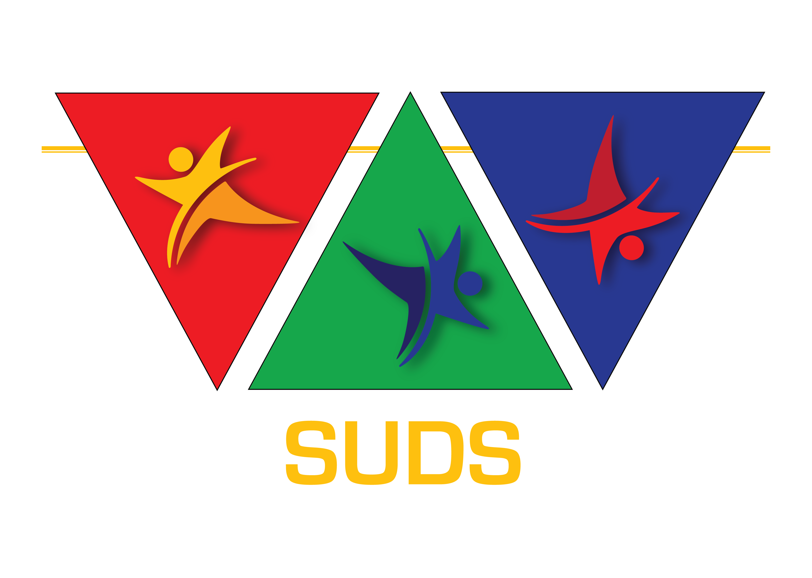

If you are already registered for a sport, register for an ADDITIONAL SPORT by completing the form below:

Athlete name:

Date of birth:

Mosaic ☐ Trisomy 21 ☐

Country:

National organisation:

Contact person name:

E-mail address:

Current SU-DS registration number:

New sport:

Payment of €5 per new sport is payable

Email completed form to:
registration@su-ds.org

