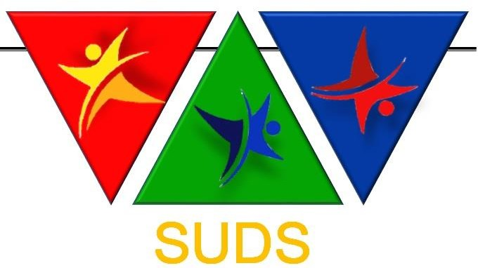
Appendix 1 : MEMBERSHIP APPLICATION FORM IDSSF (International Sport for athletes with Down Syndromes Federations)

All associations seeking membership of SUDS should use this form. This form should be completed in English. All parts should be completed. Once complete, the form should be sent to SUDS President.

The application will be considered by the Executive Committee of SUDS.

Name of applicant: IDSSF

Country:

Address:

Address for correspondence (if different):

Phone and fax number (including international dialling code) Phone:
Fax:

Contact: Name

Officers of the Federation: Name of Federation

Email and Website Address Email:
Website:

President:

Secretary:
Others officials: | Name Name Name  Name | Position Position Position  Position

Do you have a formal constitution (Please attach a copy)? | Yes | No
Do you agree to comply with the World Anti-Doping Code? | Yes | No
Does your National Paralympic Committee support your application?⁹ | Yes | No
Is your application supported by your National Sports Council or recognized government department for sport? ¹⁰ | Yes | No

The Annual membership fee should be paid by direct bank transfer to the SUDS Bank Account

The President and one other Official of the Federation should sign the application.

⁹ Not essential – just for information
¹⁰ Not essential – just for information

Signed Position Date Signed Position Date
Please return this document with copies of your Constitution to the President of SUDS (vpsuds@gmail.com)

ORGANISATION OFFICIAL STAMP

